**Bhai Gurdas Polytechnic College**

**Main Patiala Road, Sangrur (Punjab)**



# TRAINING REPORT ON [TOURISM MANAGEMENT SYSTEM](http://localhost/trm/admin/dashboard.php) (PHP)

**Submitted by:**

**Praful Kumar Singh (190769507701)**

**Lavkush Kori (190769507694)**

**Shrawan Sah(190769507709)**

**Submitted to:**

**Er. NIRMAL SINGH**

**BGPC (CSE)**

**TO WHOM SO EVER IT MAY CONCERN**

This is to certify that **Praful Kumar Singh, Lavkush Kori, Shrawan Sah** (CSE) from the **Computer Science Engineering**, **BGPC, SANGRUR** undertook a project entitled. **“Tourism Management System”.** In my supervision, this work has not been submitted either in part or in full, to any other university or institute for the award of degree. It is the original efforts and work of the student and was neither submitted earlier nor copied from other reports. All the references have been mentioned at the end of the project.

**DECLARATION**

**Praful Kumar Singh, Lavkush Kori, Shrawan Sah** Roll No. **190769507701, 190769507694, 190769507709** (Semester-**6**) of the **Bhai Gurdas Polytecnic College** hereby declare that the Training Report entitled **“Tourism Management System “** is an original work and data provided in the study is authentic to the best of my knowledge. This report has not been submitted to any other Institute for the award of any other degree.

**INDEX**

|  |  |
| --- | --- |
| **CHAPTER** | **PAGE** |
| 1. **Introduction**    1. Introduction of Project    2. Objective of the Project    3. Scope of Project    4. Tools and Techniques 2. **Details of Using Website**    1. User Login 3. **System Analysis & Specification**    1. System Analysis    2. Investigation Phase 4. **Practical Application and Implementation**    1. VS CODE    2. PHPMyAdmin 5. **Reference**    1. Xammp Server    2. Apache    3. Bootstrap and HTML    4. JavaScript   6.5 Css (Cascading Style Sheet | **5-6**  **7-29**  **30-30**  **31-32**  **33-35**  36-40 |

**Introduction**

* 1. **Introduction Of Project**

This website is based on the friend to support for Tourism Management System. This project will be handling using HTML, CSS, and JavaScript &PHP. This project will hold all the activities of Tourism Management System

Today is competitive world. Everything is going to be online. So keeping in view the need of this, my project is on website development. I have developed the website of Tourism Management System.

* 1. **Objectives Of Project**

This project is based on php language. The main of this project is to provide to give Hostel Management System.

1. Centralization of data

2. Make the system computizea

3. Reduce the time consumptions

4. No paper work requirement.

5. Easy data searching and updating.

* 1. **Scope of project**

Nothing is perfect in this world. So we are also no exception. Although, we have tried our best to present the information effectively yet, there can we further enhancement in the application. we have taken care of all the critical aspects which needs to take care of during the development of the project.

Like the things this project also has some limitations and can further be enhances by someone, because there are certain drawbacks that do not permit the system to be 100% accurate.

* 1. **Tools and Techniques**

Front End = PHP

Back End = MYSQL

Server = Xammp

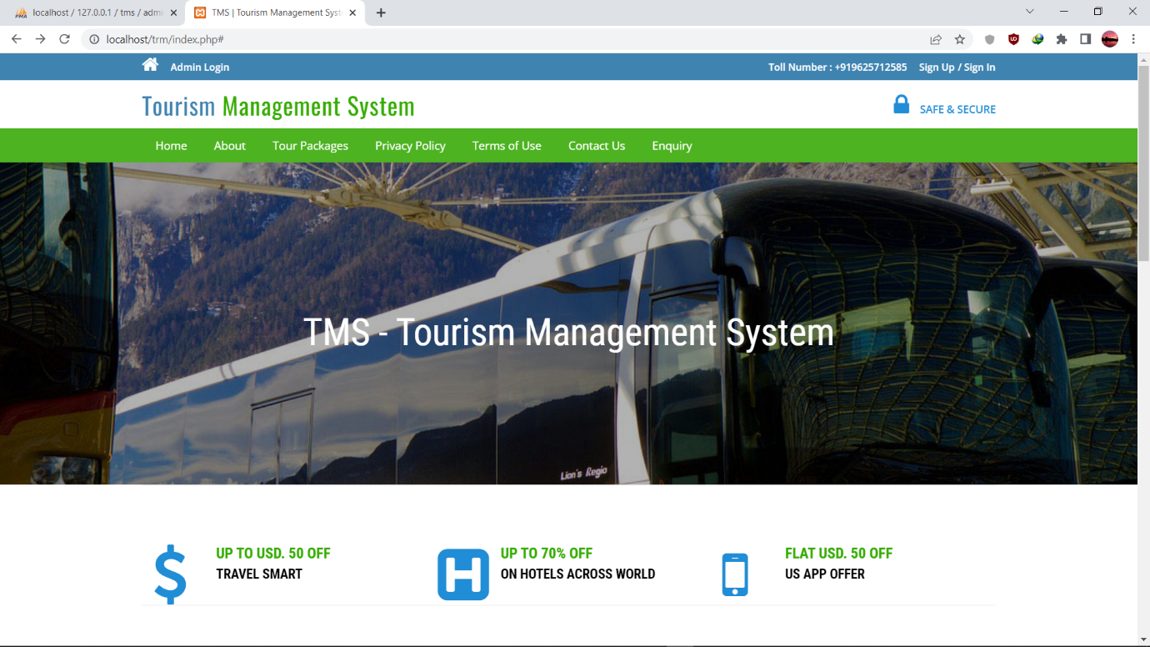**HOME:-Admin Login:-**

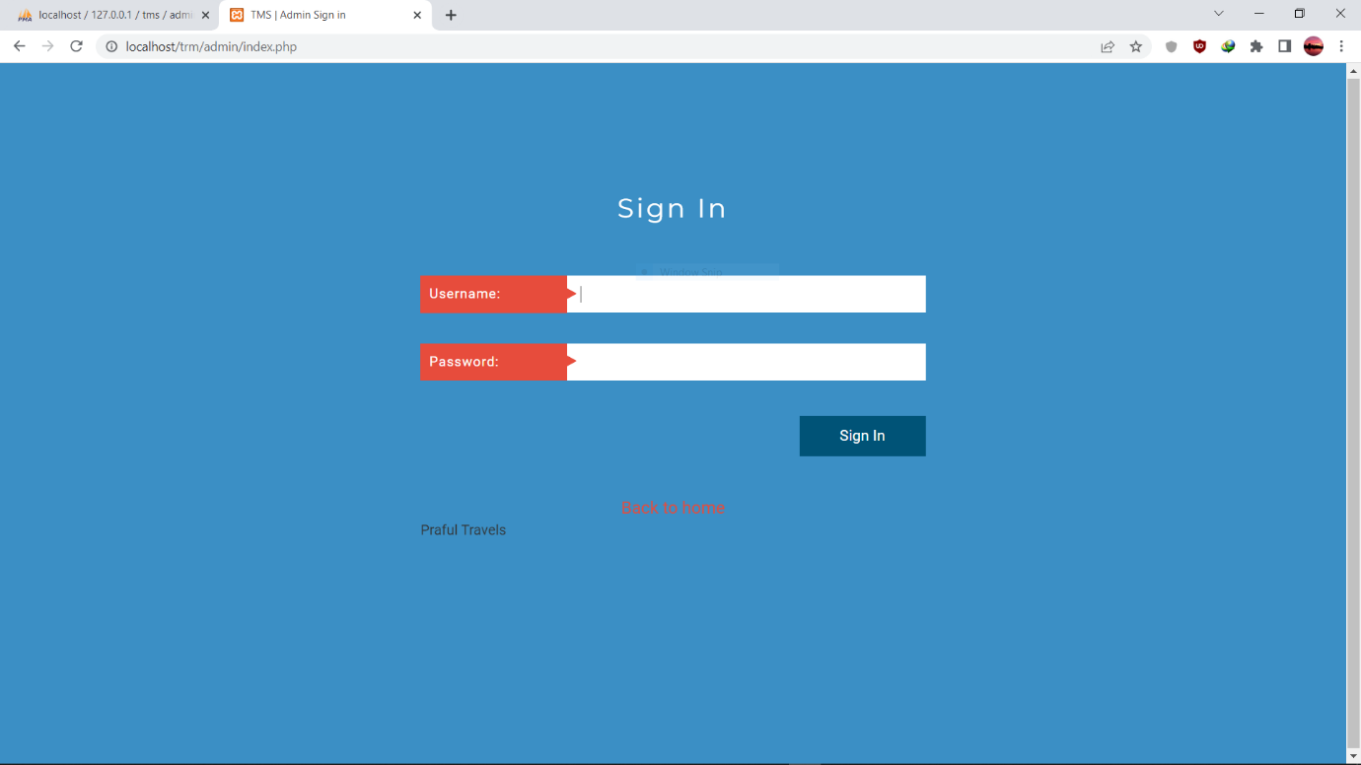

**Admin Home:-**

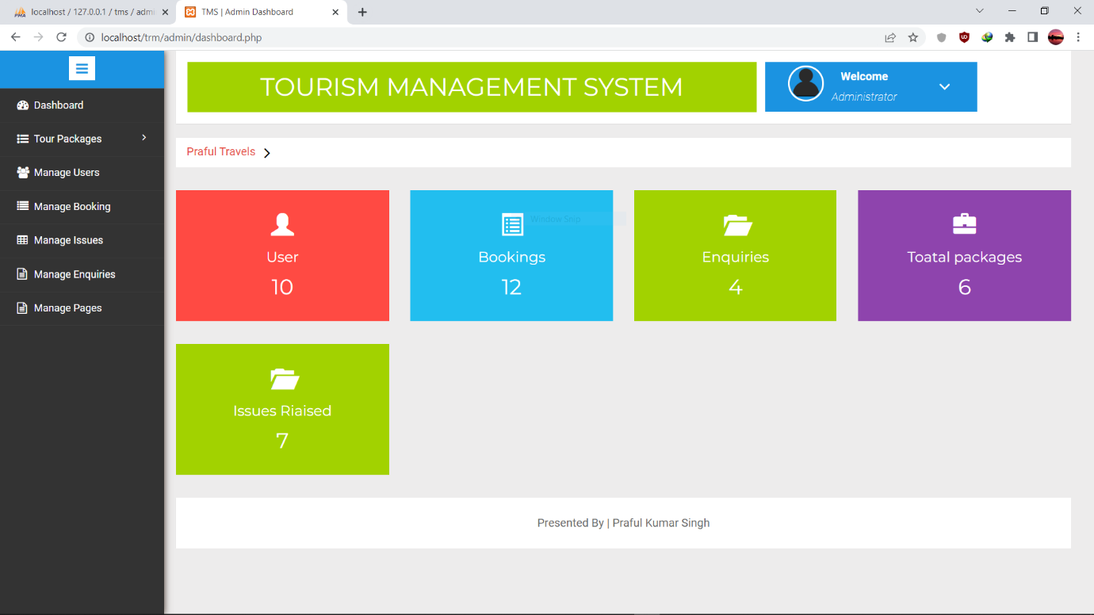

**Admin Password Change:-**

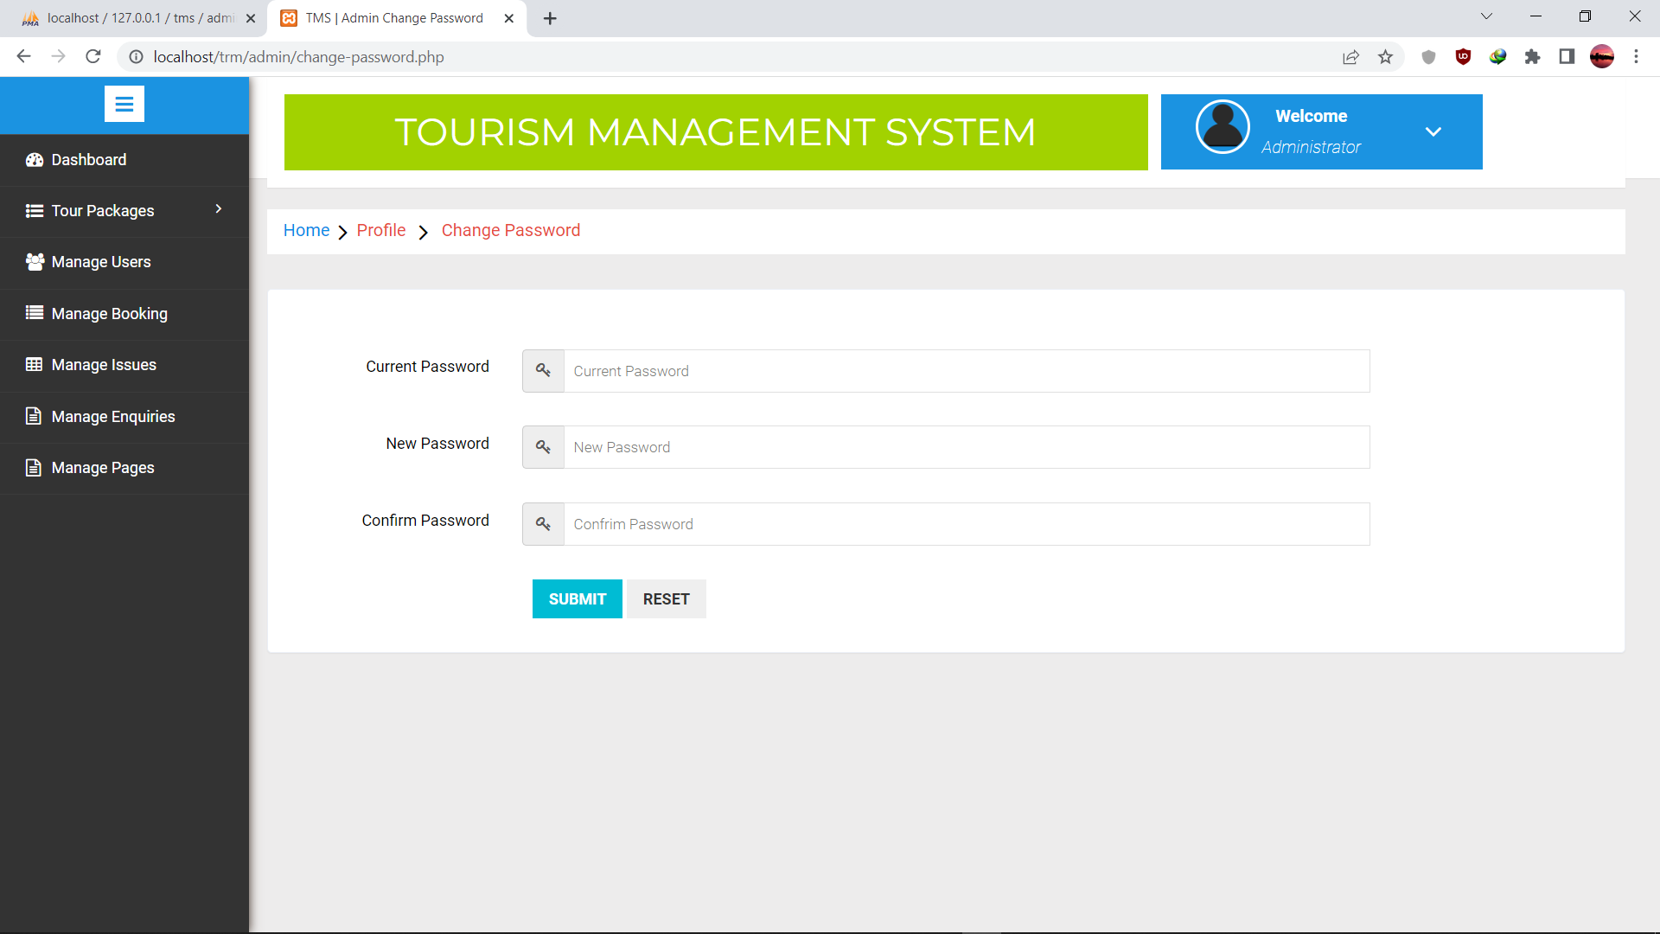

**Create Tour Package:-**

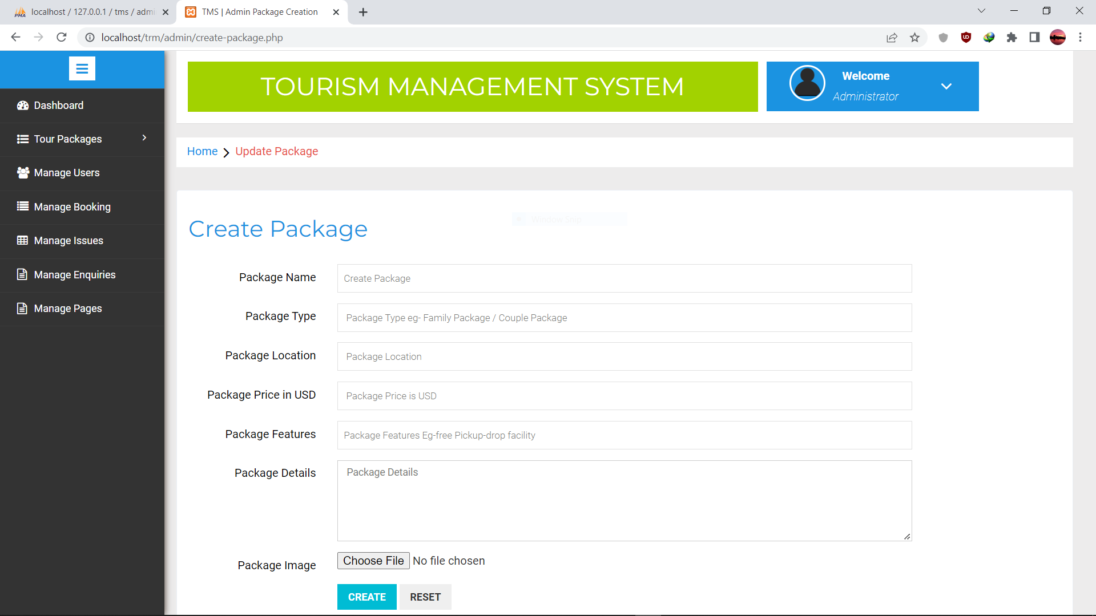

**Manage Tour Package:-**

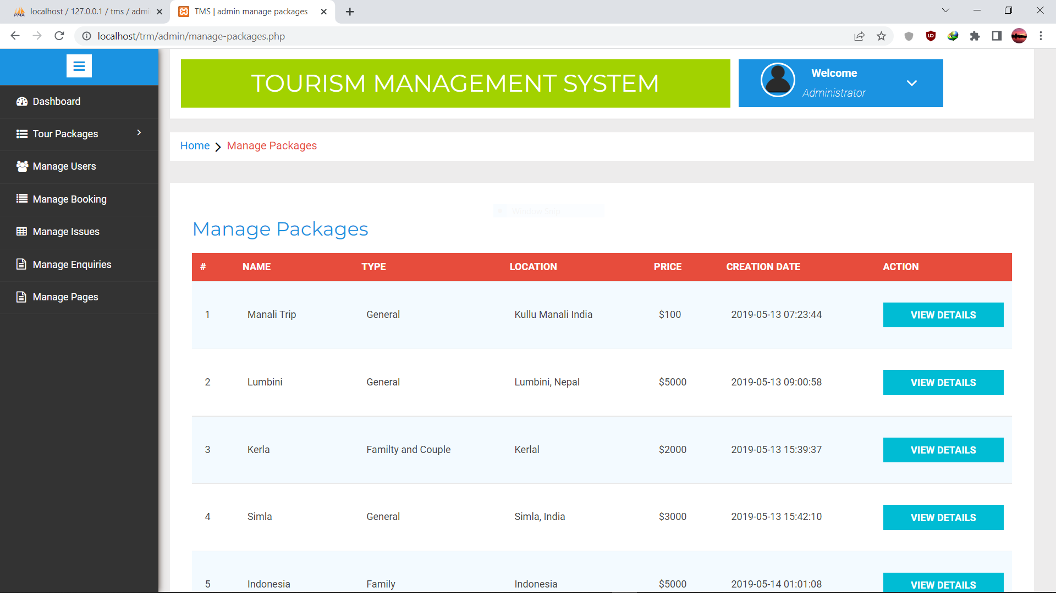

**Manage Inquiry:-**

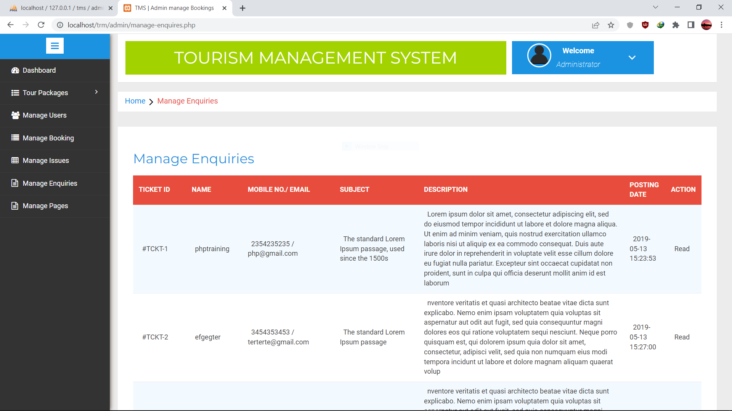

**Manage Booking:-**

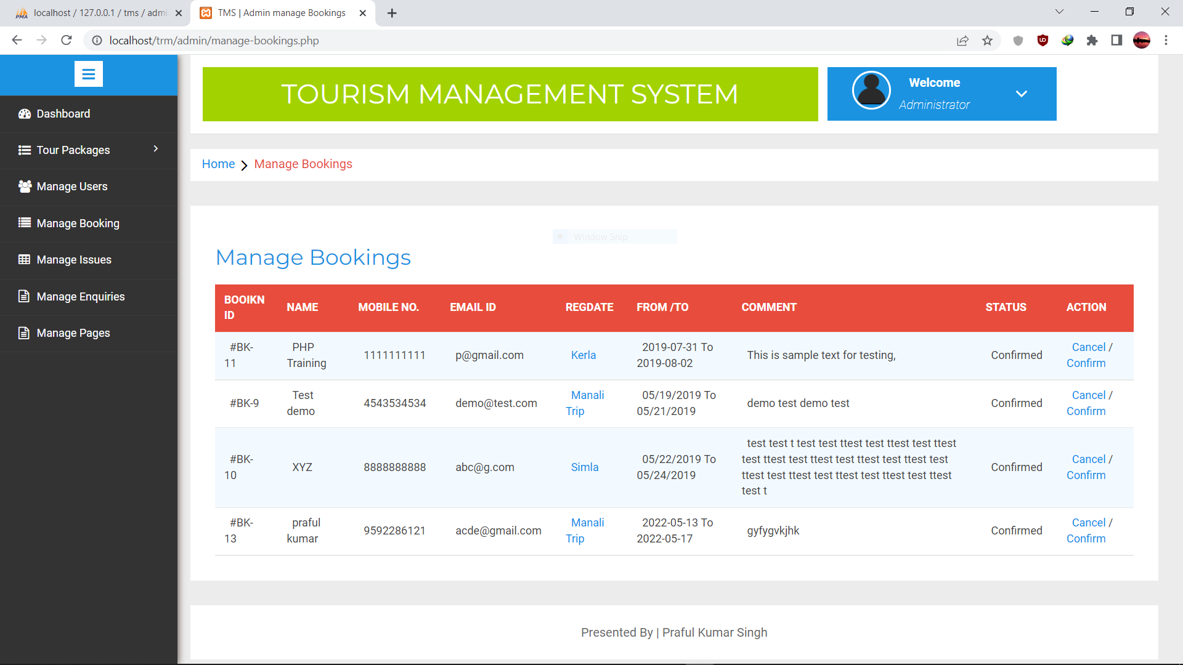

**Manage Issue:-**

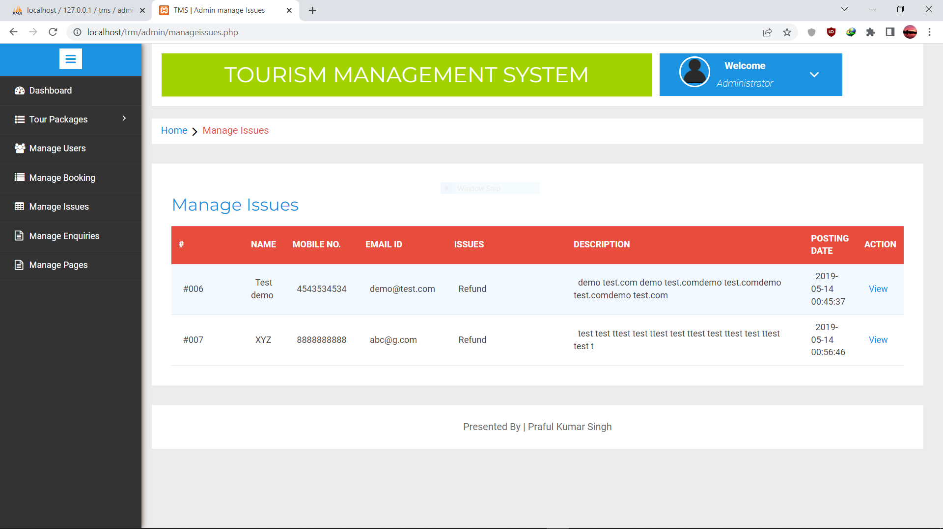

**Manage Page:-**

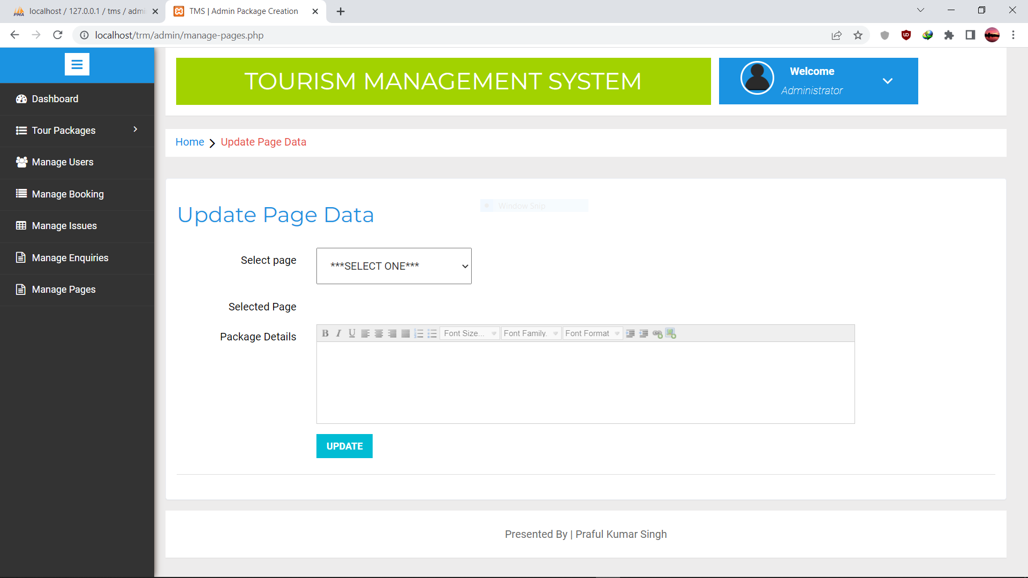

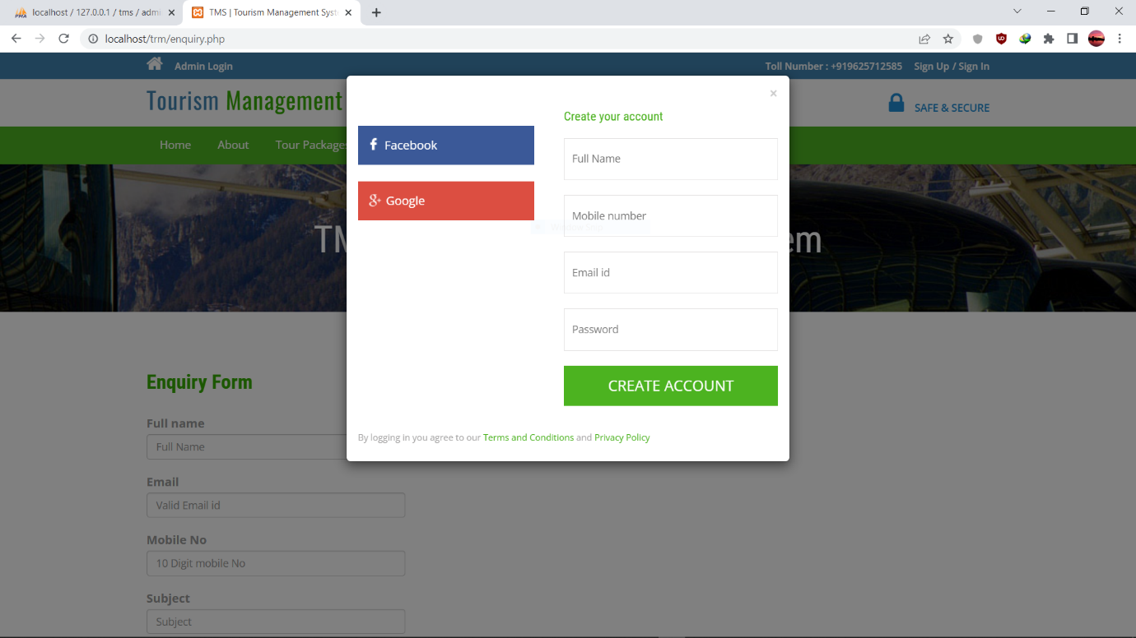**SIGN UP:-**

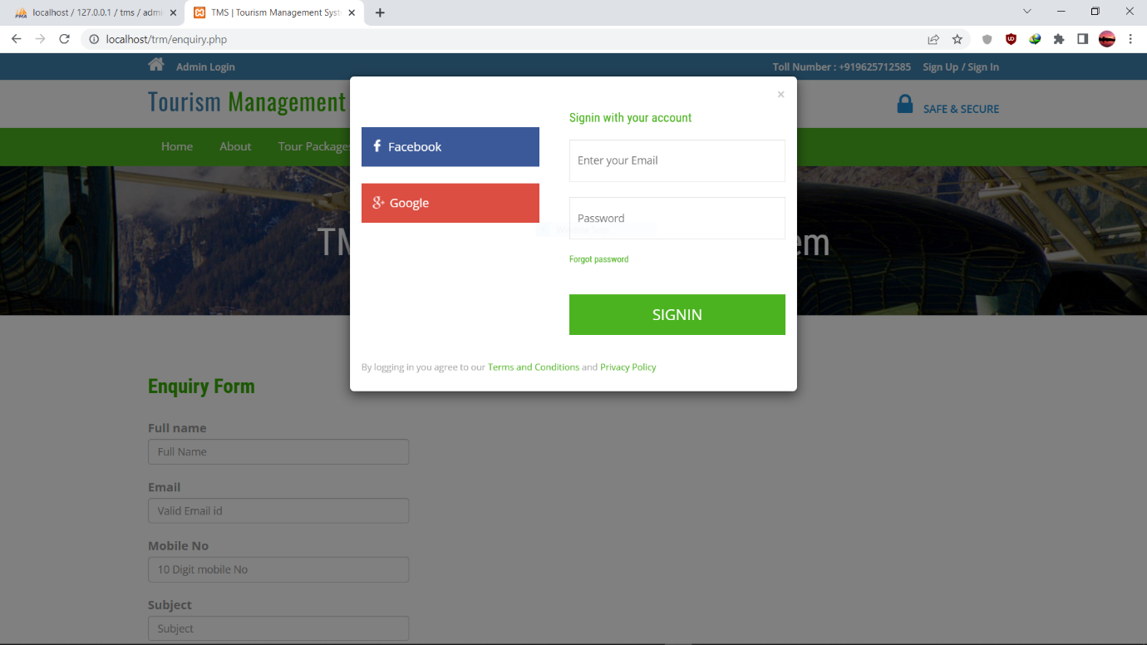**SIGN IN:-**

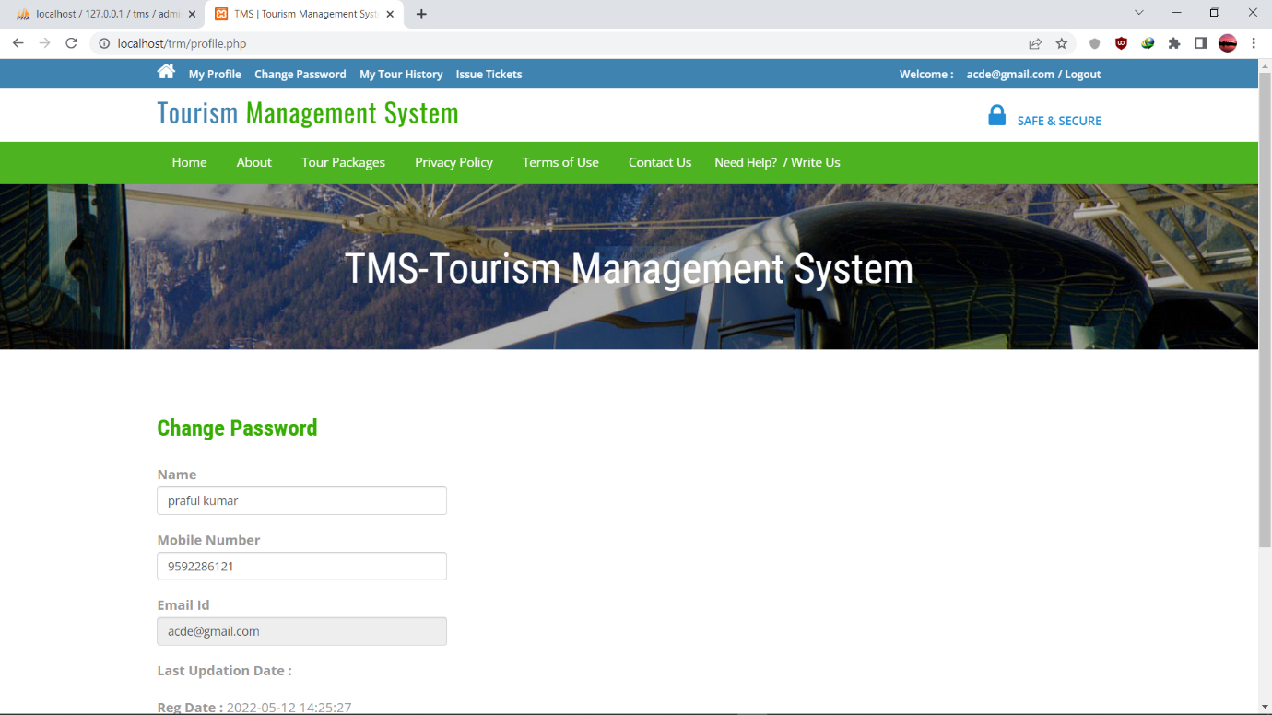**USER CHANGE PASSWORD:-**

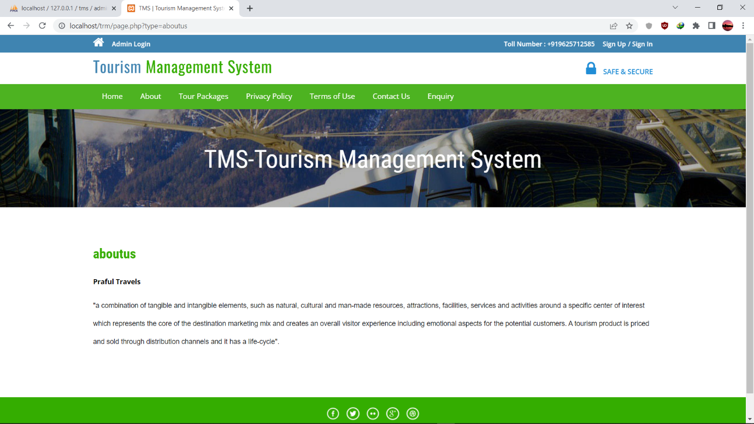**ABOUT US:-**

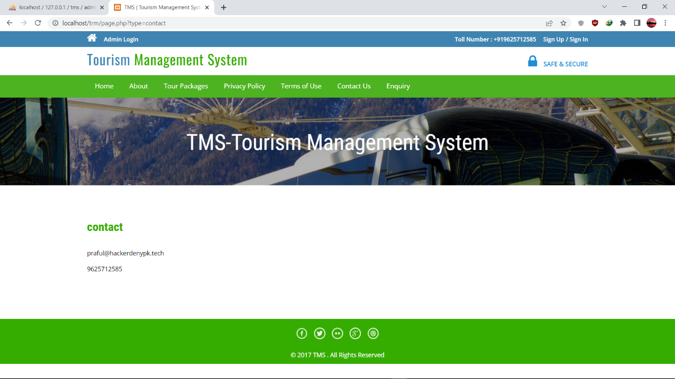**CONTACT US:-**

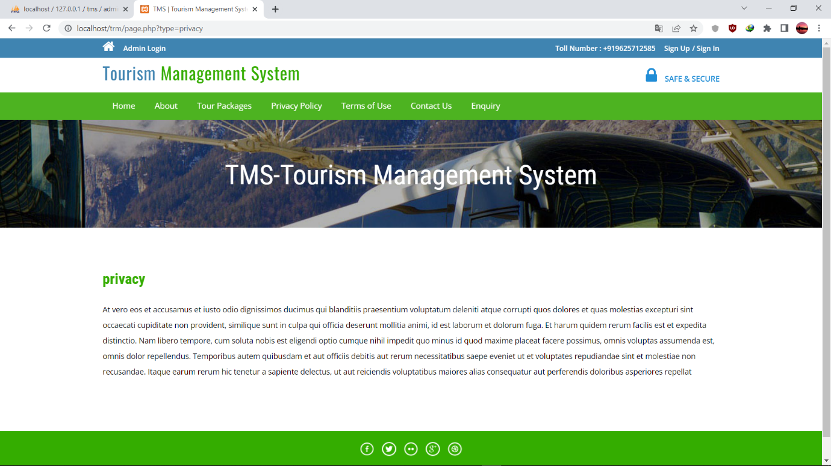**PRIVACY:-**

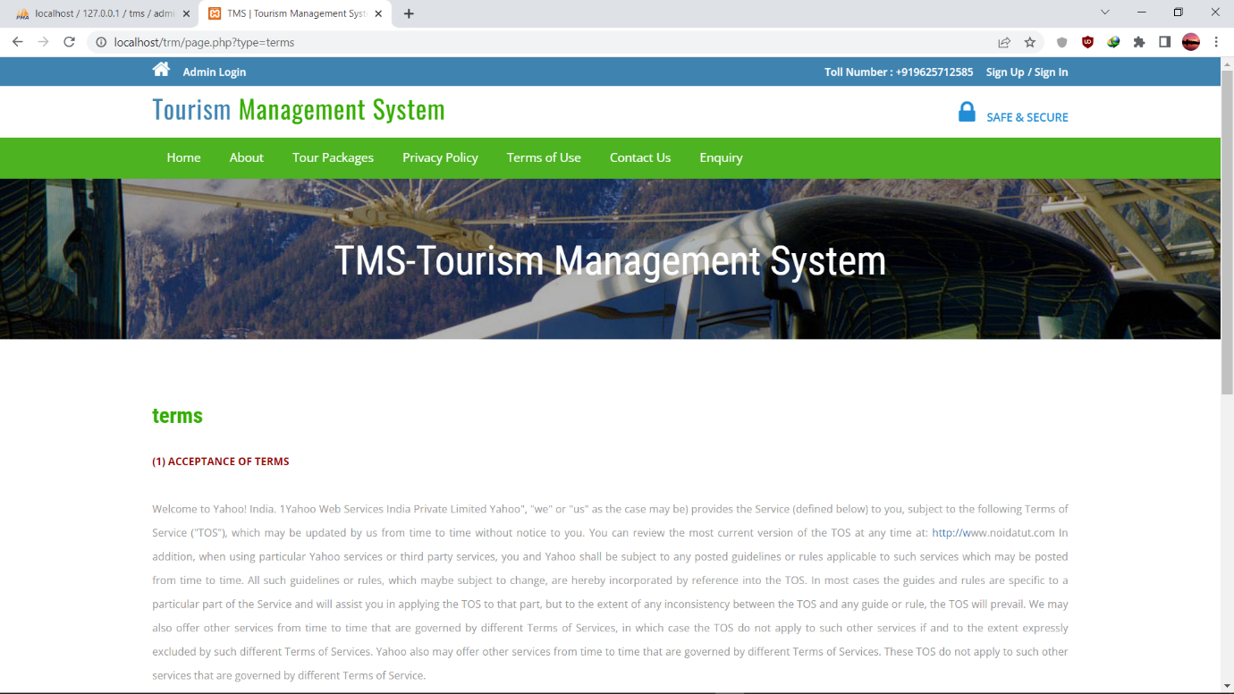**TERMS AND CONDITIONS:-**

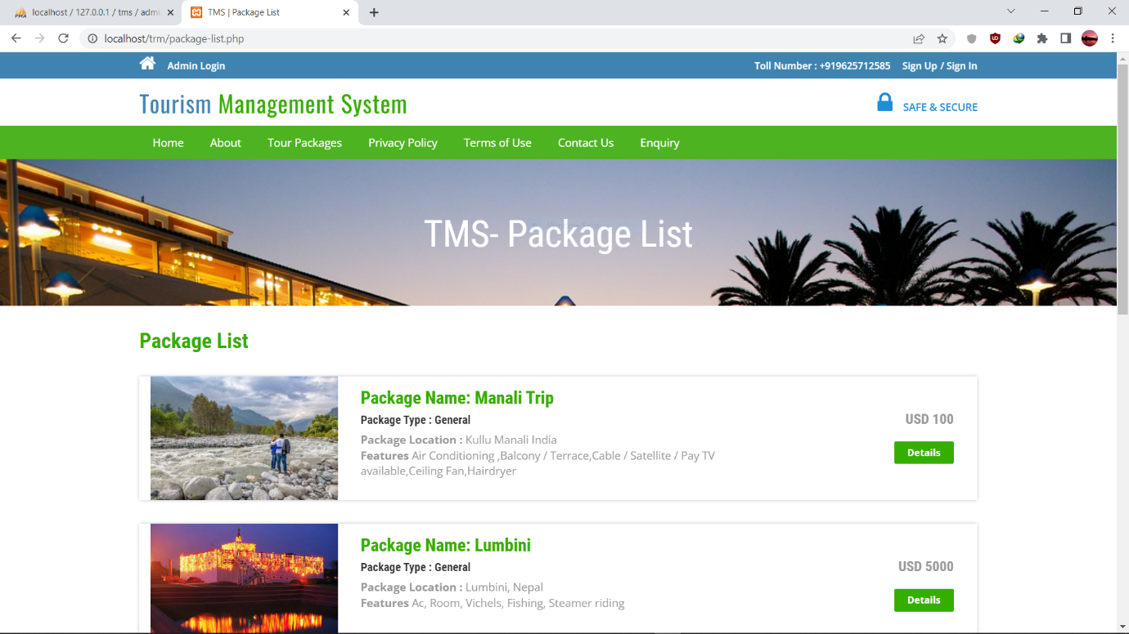**PACKAGE LIST:-**

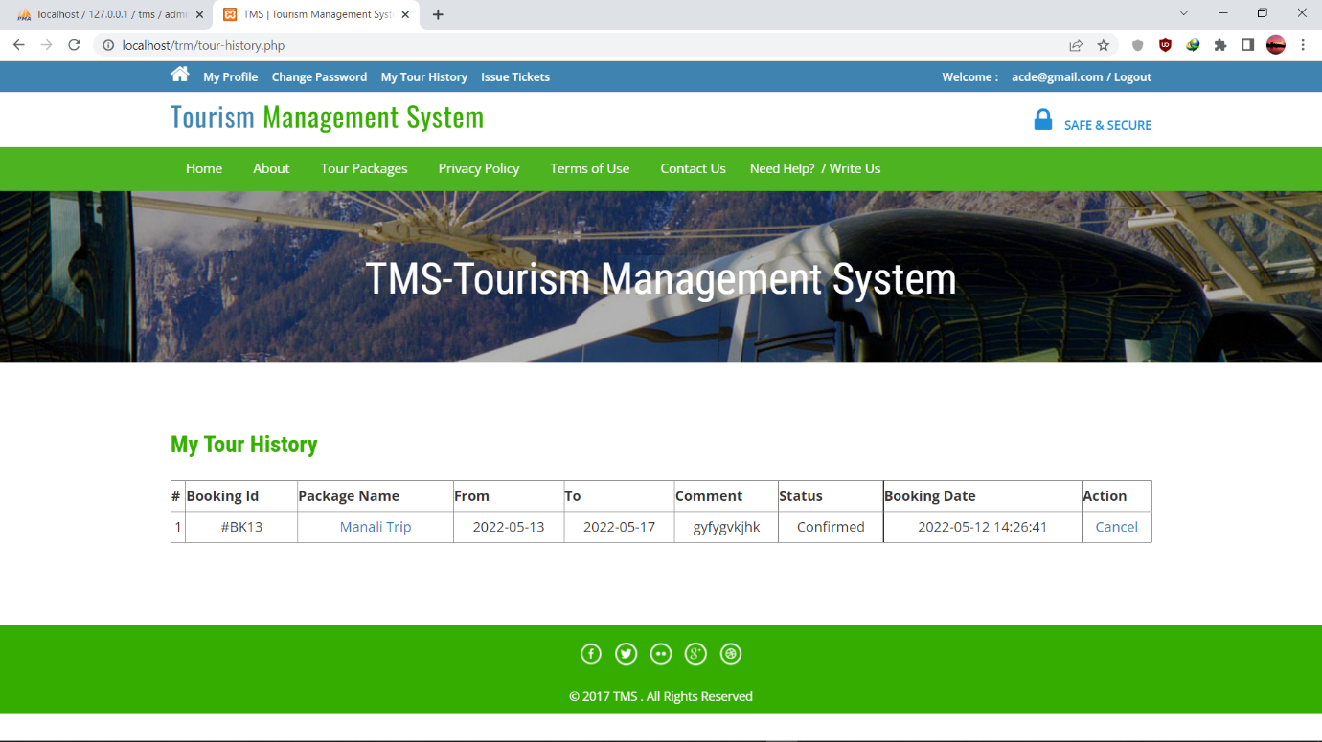**TOUR HISTORTY:-**

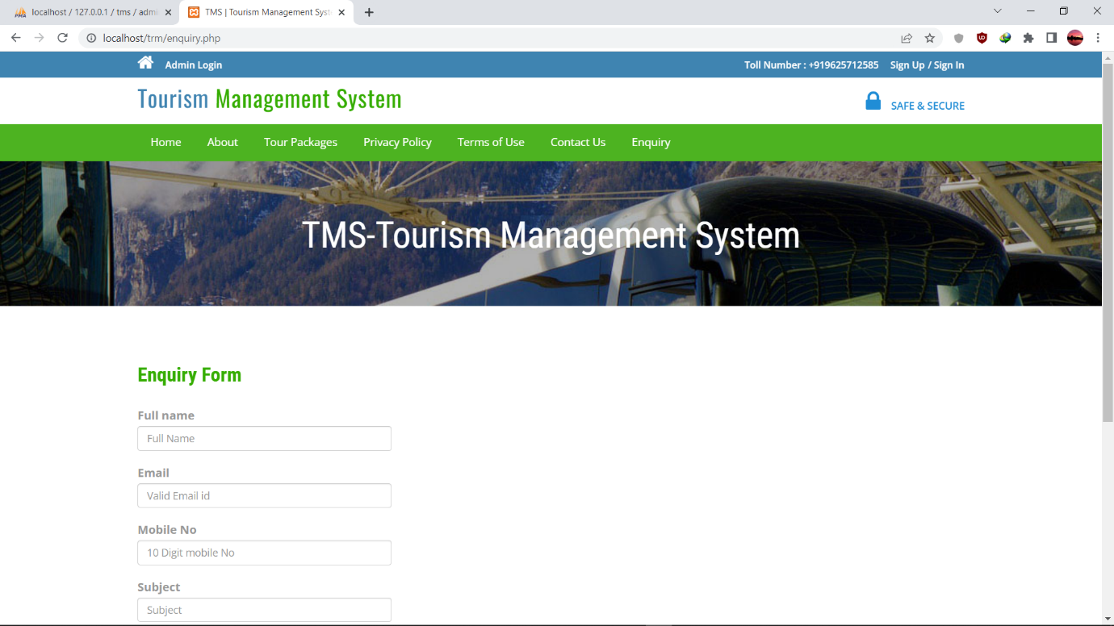**ENQUIRY FORM:-**

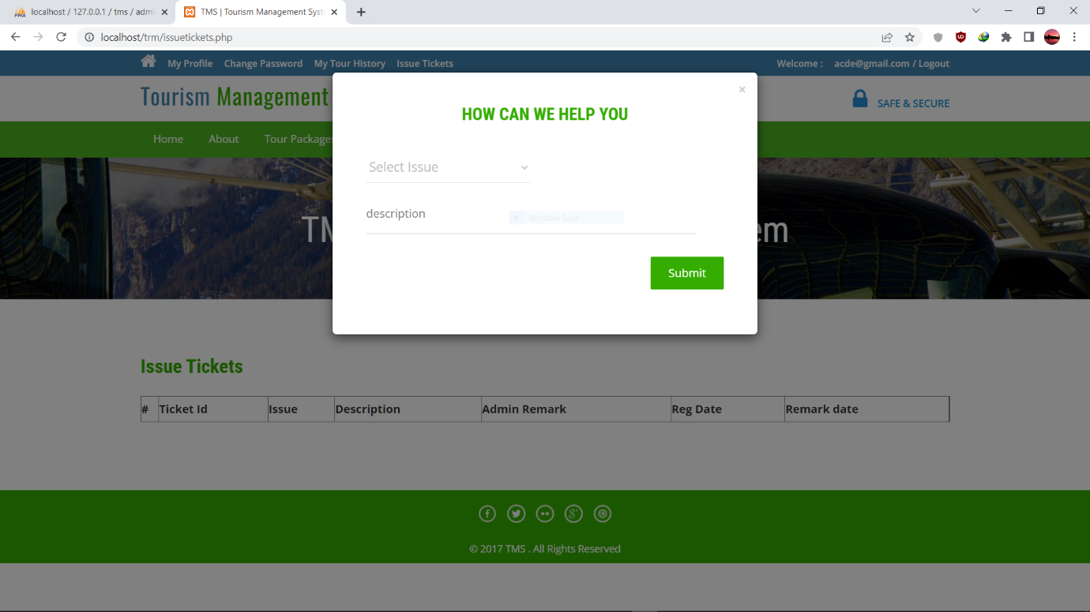**USER HELP:-**

**DATABASE:-**

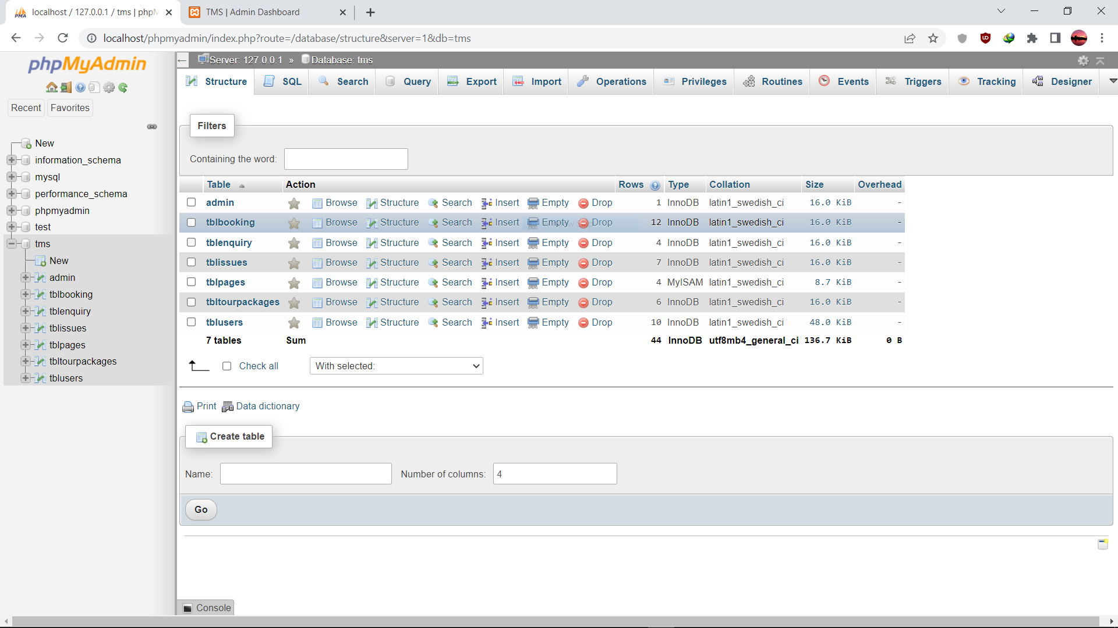**System analysis and Specification**

* 1. **System Analysis**

System analysis is the process of studying the business processes and procedures, generally referred to as business systems, to see how they can operate and whether improvement is needed.

This may involve examining data movement and storage, technology used in the system, programs that control the ensure system, people providing inputs, doing the processing and receiving the outputs.

**3.2 Investigation Phase**

The investigation phase is also known as the fact-finding stage or the analysis of the current system. This is a detailed study conducted with the purpose of fully understand the existing system and to identify the basic information requirements. Various techniques may be used in fact-finding and all fact obtained must be recorded.

As it was essential for us to find out more about the present system, we used the following methods to gather the information: -

* + 1. **Observation:** Necessary to see the way the system works first hand.
    2. **Document sampling: -** These are all the documents that are used in the system. They are necessary to check all the data that enters and leaves the system.

**System Design**

**4.1 Data Flow Diagram**

Data flow diagram (DFD) represents the flows of data between different processes in a business. It is a graphical technique that depicts information flow and the transforms that are applied as data move from input to output. It provides a simple, intuitive method for describing business processes without focusing on the details of computer systems. The data flow diagram is also known as “bubble chart”. A DFD consists of series of a bubbles joined by lines. The bubbles represent data transformation and the lines represent the data flow in the systems.

Data flowcharts can range from simple, even hand-drawn process overviews, to in-depth, multi-level DFDs that dig progressively deeper into how the data is handled. They can be used to analyze an existing system or model a new one. Like all the best diagrams and charts, a DFD can often visually “say” things that would be hard to explain in words, and they work for both technical and nontechnical audiences, from developer to CEO. That’s why DFDs remain so popular after all these years. While they work well for data flow software and systems, they are less applicable nowadays to visualizing interactive, real-time or database-oriented software or systems.

**DFD for user**

User

BOOK TICKET

**DFD for Admin**

Admin

Dashboard

**Practical Application and Implementation**

**5.1 VS CODE**

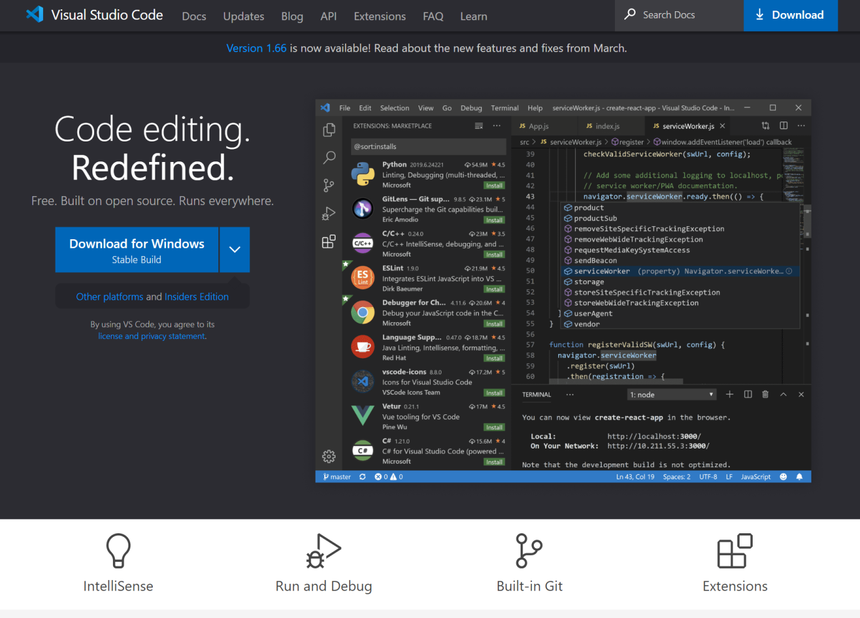

**Visual Studio Code, also commonly referred to as VS Code, is a source-code editor made by Microsoft for Windows, Linux and macOS. Features include support for debugging, syntax highlighting, intelligent code completion, snippets, code refactoring, and embedded Git. Users can change the theme, keyboard shortcuts, preferences, and install extensions that add additional**

**5.2 PHPMyAdmin**

PHPMyAdmin is open source free software, designed to handle the administration and management of MySQL databases through a graphic user interface. Written in PHP, PHPMyAdmin has become one of the most popular web-based MySQL management tools. PHPMyAdmin comes with detailed documentation and is being supported by a large multi-language community. PHPMyAdmin ever growing list of features supports all commonly used operations such as browsing, dropping, creating, altering MySQL databases, tables, fields and indexes. Also, PHPMyAdmin enables you to manage MySQL users and user privileges.

Another commonly used PHPMyAdmin feature is its import function. With PHPMyAdmin, MySQL database import from backup is made easy and you can import an SQL database with a few mouse clicks. phpMyAdmin comes with a wide range of [documentation](https://www.phpmyadmin.net/docs/) and users are welcome to update [our wiki pages](https://github.com/phpmyadmin/phpmyadmin/wiki) to share ideas and howtos for various operations.

The [phpMyAdmin team](https://www.phpmyadmin.net/team/) will try to help you if you face any problem; you can use a [variety of support channels](https://www.phpmyadmin.net/support/) to get help.phpMyAdmin is also very deeply documented in a book written by one of the developers – [Mastering phpMyAdmin for Effective MySQL Management](https://www.packtpub.com/big-data-and-business-intelligence/mastering-phpmyadmin-34-effective-mysql-management), which is available in English and [Spanish](https://www.phpmyadmin.net/docs/#books).

To ease usage to a wide range of people, phpMyAdmin is being translated into [72 languages](https://www.phpmyadmin.net/translations/) and supports both LTR and RTL languages.

phpMyAdmin is a mature project with a stable and flexible code base; you can find out more about the [project and its history](https://www.phpmyadmin.net/about/) and the [awards](https://www.phpmyadmin.net/awards/) it earned. When the project turned 15, we published a [celebration page](https://www.phpmyadmin.net/15-years/).

The phpMyAdmin project is a member of [Software Freedom Conservancy](https://sfconservancy.org/). SFC is a not-for-profit organization that helps promote, improve, develop, and defend Free, Libre, and Open Source Software (FLOSS) projects.

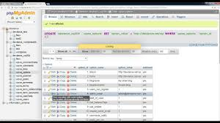

(PHPMyAdmin)

**Create a new table in PHPMyAdmin**

Navigate to your cPanel->**PHPMyAdmin** tool and open the newly **create database**. It is empty and there are no tables. Enter the table name and the number of fields. Click on the Go button to **create** the table.

Import data from CSV and SQLExport data to various formats: CSV, SQL, XML, PDF, ISO/IEC 26300 –

Open Document Text and Spreadsheet, Word, LATEX and others

Administering multiple servers

Creating graphics of your database layout in various formats

Creating complex queries using Query-by-example (QBE)

Searching globally in a database or a subset of it

**Reference**

The system must have the following software requirements:

* 1. **Wamp Server:**

Stands for "Windows, Apache, MySQL, and PHP." WAMP is a variation of [LAMP](https://techterms.com/definition/lamp) for

Windows systems and is often installed as a [software](https://techterms.com/definition/software) bundle (Apache, MySQL, and

PHP). It is often used for [web development](https://techterms.com/definition/web_development) and internal testing, but may also be used to

Server live websites.

The most important part of the WAMP package is [Apache](https://techterms.com/definition/apache) (or "Apache HTTP

Server") which is used run the [web server](https://techterms.com/definition/web_server) within Windows. By running a local Apache

Web server on a Windows machine, a web developer can test [WebPages](https://techterms.com/definition/webpage) in a [web browser](https://techterms.com/definition/web_browser).

WAMP also includes [MySQL](https://techterms.com/definition/mysql) and [PHP](https://techterms.com/definition/php), which are two of the most common technologies

Used for creating [dynamic websites](https://techterms.com/definition/dynamicwebsite). MySQL is a high-speed database, while PHP is a

Scripting language that can be used to access data from the database. By installing these

Two components locally, a developer can build and test a dynamic website before

Publishing it to a public web server.

While Apache, MySQL, and PHP are open source components that can be installed

Individually, they are usually installed together. One popular package is called

"WampServer," which provides a user-friendly way to install and configure the "AMP"

Components on Windows.

**6.2 HTML:**

HTML is a **markup** language for **describing** web documents (web pages).

6.2.1 HTML stands for **H**yper **T**ext **M**arkup **L**anguage.

6.2.2 A markup language is a set of **markup tags.**

6.2.3 HTML documents are described by **HTML tags.**

6.2.4 Each HTML tag **describes** different document content.

**6.3JavaScript:**

JavaScript is a programming language. We use it to define behavior of web pages. It is also lightweight and an interpreted programming language.

In 1993, Mosaic, the first popular web browser, came into existence. In the year 1994, Netscape was founded by Marc Andreessen. He realized that the web needed to become more dynamic. Thus, a 'glue language' was believed to be provided to HTML to make web designing easy for designers and part-time programmers. Consequently, in 1995, the company recruited Brendan

**JavaScript is a MUST for students and working professionals to become a great Software Engineer especially when they are working in Web Development Domain. I will list down some of the key advantages of learning JavaScript: 1. JavaScript is the most popular programming language in the world and that makes it a programmer’s great choice. Once you learnt JavaScript…**

There are following features of JavaScript:

1. All popular web browsers support JavaScript as they provide built-in execution environments.

2. JavaScript follows the syntax and structure of the C programming language. Thus, it is a structured programming language.

3. JavaScript is a weekly typed language, where certain types are implicitly cast (depending on the operation).

JavaScript is used to create interactive websites. It is mainly used for:

* Client-side validation.

**6.4 CSS-CASCADING STYLE SHEET:**

CSS is a language used to detail the presentation of a web page's markup language (most commonly HTML or XHTML) – such as colors, fonts, and layout. One of its key benefits is the way it allows the separation of document content (written in HTML or a similar markup language) from document presentation (written in CSS). In other words we can say that, CSS is a language that describes the style of an HTML document.CSS describes how HTML elements should be displayed.

Cascading Style Sheets (CSS) is a programming language that’s useful to determine the design of electronic documents. With the help of simple instructions – presented as clear source code – website elements such as layout, color, and typography can be adapted as is desired. Thanks to the Cascading Style Sheets, the semantic structure and the content of the document remain unaffected. CSS emerged in the mid-1990s and is now considered the **standard style sheet language** across the World Wide Web.

**6.5 AJAX:**

AJAX is an acronym for **Asynchronous JavaScript and XML**. It is a group of

Inter-related technologies like JavaScript, DOM, XML, HTML, CSS etc.

AJAX allows you to send and receive data asynchronously without reloading

The web page. So it is fast.

AJAX allows you to send only important information to the server not the entire

Page. So only valuable data from the client side is routed to the server side. It

Makes your application interactive and faster.

An object of **XMLHttpRequest** is used for asynchronous communication

between client and server.

It performs following operations:

1. Sends data from the client in the background.

2. Receives the data from the server.

3. Updates the webpage without reloading it.

**THANKS…**